January 2024

Hello everyone
Happy New Year – let’s hope it’s more peaceful one.
Many thanks to all who have sent news this time. It’s great to be able to welcome some new contributors.

Tricia Gibb (St Albans)
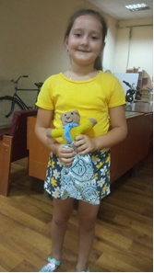
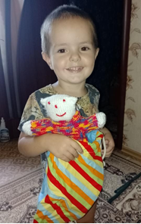
In August I handed over 466 teddies to go to Poland from where they went to Ukraine with a charity organising food parcels for people all over Ukraine. They like to put a teddy in each box. Since then, just over 500 more Teddies have gone to Poland for Ukraine. This means that in the past 18 months or so, over 2500 Teddies have now gone to Ukraine plus another 255 which I sent last year to welcome centres in County Durham and Edinburgh for Ukrainian refugees. Thanks to all for making this possible but we need to keep the Teddies coming, as I have been told that the charity would like more to include with their food parcels.
“We are so very grateful for these lovely teddies which put smiles on the faces of young and old alike. They comfort and melt hearts and provide a lovely distraction in all sorts of circumstances. Please pass on our grateful thanks to all knitters.”
Here’s to another year of bringing a little happiness to children affected by the terrible events in the world.

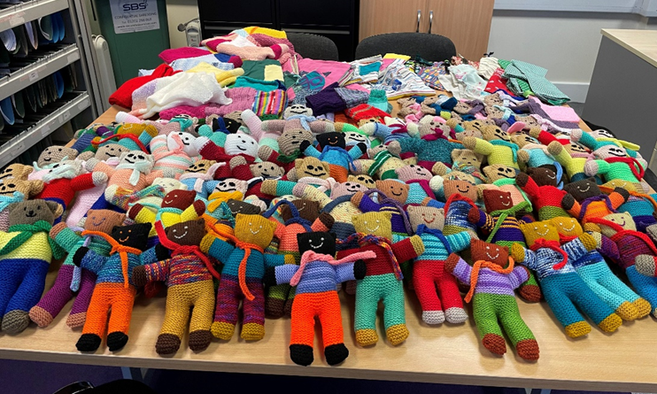
Angela Turner (Essex) When I first took on the role of collecting and distributing teddies and other items in Essex, I initially had problems finding knitters. However I am pleased to say that I have since been contacted by many generous ladies and gentlemen who have produced some beautiful teddies, blankets, hats, mittens and bags and more.
I work for Essex Chambers of Commerce and our CEO has given me a pot of money to purchase wool and stuffing for our knitters.
Through Essex Chambers I have been able to provide the teddies and other items to some wonderful homes. Due to work commitments a colleague has been distributing the bears on my behalf. She recently delivered some to Essex Police, who emailed me to say, ‘Just wanted to say to thank you to you, the team at Chambers of Commerce, and Teddies for Tragedies, for the wonderful bears delivered last week. They really are super and will come in useful for many of our teams within Essex Police, who are dealing with children who need comforting.’
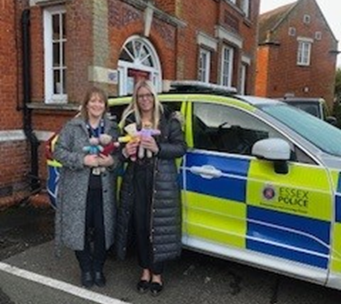
Before Christmas we delivered to St. Vincents Centre in Southend on Sea. They are a charity that supports vulnerable and homeless people, as well as many families who are struggling. They were overwhelmed with the donations and we will continue to support them in the coming months with more wonderful knits!

Jean Salter (Oxfordshire) Every Friday morning is the time for our Knit and Natter group in Cholsey as knitters get together in the Pavilion to make Teddies and blankets. Our blankets continue to be distributed in Ukraine via Hope and Aid Direct and we have received some lovely feedback and photographs. We are producing at least 12 large single blankets every month and we have now made nearly 200 since the start of the war in Ukraine.
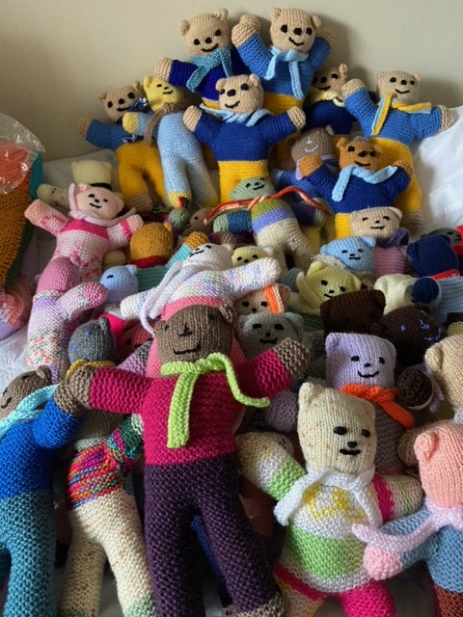
We had a stall at the village Horticultural Show at the end of September where we were not only promoting the work of our group, but also the work of Hope and Aid Direct. It was a great success and we were very pleased to have many people supporting the stall and showing interest in our work. As a resul,t we received many more donations of unwanted wool. On the stall we sold items made from some of the previously donated wool that was unsuitable for the blankets: dishcloths from cotton, toys from chunky and hats and scarves from chunky or speciality yarn. After making a donation to help with H&A transport costs we still have a healthy wool fund which helps buy double knitting wool to make blankets and Teddies over the winter.
Teddies are sent to Tricia in St Albans and with the latest batch about to go, our two Teddy knitters, Anita and Pat, have produced 180 this year. All colours with a number dressed in blue and yellow ready to find their way to Ukraine!

Susan Mulligan (Yorks) As usual I have sent everything to Africa. I have sent 450 teddies, 18 Blankets, 18 Jumpers, 20 Hats, 5 Baby sets as well as 300 Sanitary towels. I have another car full of things ready to take to the warehouse which I haven't included in this audit. As well as the items specifically for sending to Africa, I also take lots of items for them to sell in their small shop which along with all the donations raised locally, raises the funds to pay for the containers.

Sue Gorrie (Fylde, Lancs) The group at Fleetwood library has dwindled to just 2 regulars and 2 who come when they can! We continue to make prem baby items which go to Preston hospital and the occasional blanket which is given to needy people in the Preston area. We may have an outlet for children’s clothing to go to Syria but don’t know yet if the lady is still willing to take items! We applaud all those lovely knitting groups featured in your newsletter and wish we could join them!

Sue Hoskinson (Bucks) We continue to supply knitted blankets for Hope and Aid Direct to take to Ukraine. I managed to get 50 + completed blankets to my DOP Janet over the past weeks alone. Squares arrive all the time with me and also with Gill Harste in Ingastone Essex. I know other DOP’s all round the country are receiving completed blankets too. I am making another delivery to Janet shortly. Just to let you know the 50th Hope and Aid Direct convoy trucks have arrived in Kyiv where they have had their first snow of the harsh Winter. So a huge 'Thank you’ from me to all my knitters for their hard work and continued support. The last backload to Ukraine by H&AD was not just any old truck load, this was the 50th truck of aid that they have been involved in moving to Ukraine since the start of the conflict. Somehow they have averaged one truck every 12 days. Incredible!
If any other distributor would like to donate squares or blankets to this, you can find a DOP near you by visiting www.hopeandaiddirect.org.uk/drop-off-point

Carole Thorn (Spain) Here on the Costa Blanca the weather has been unbelievably kind but really we could do with some rain. At the beginning of December on a lovely sunny Friday morning we held a stall at the local market. I wish I had a picture but I’m afraid not so will just have to say how good it looked with loads of tiny hedgehogs, little dolls and teddies, plus all the knitted clothes. One of our ladies knitted some lovely Christmas wreaths and they sold very well.
Our needles and crochet hooks have been very busy and we have some very welcome new members.
Many blankets have been donated to the local hospital and all of the toys and baby clothes not sold went to local children’s homes.
The money raised from sales has gone to local charities including the Alzheimer’s society.
I think that’s about it from me and keep the needles going everyone. I look forward to reading your news

Anne Jones (Northampton) My link to Armenia no longer want teddies but are happy to have knitted tops and blankets. However I can pass on teddies to baby basics and the food banks and also be open to requests from abroad, so I am happy to receive them. This teddy was one of many sent to Ukraine in time for Christmas.

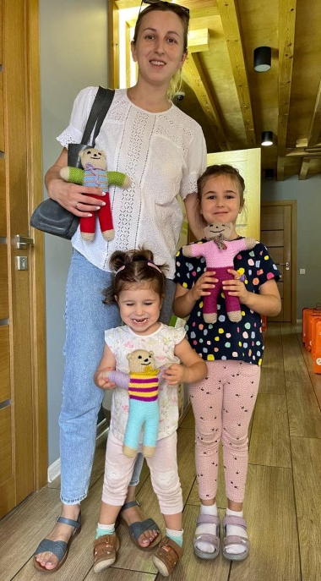
Alison McCrindle (Ontario, Canada) In August, we were so pleased to receive some videos and photos of bears, that had been made by our knitters, being distributed to children in Ukraine. (Photo right)
Our Annual Teddy Bear Tea took place in October. The volunteers at Duff’s Presbyterian Church held another lovely event and 455 bears were delivered that day. Melody Wren, a travel journalist, shared her stories of giving back to the countries that she visits. Before Melody travels, she finds charitable organizations looking for donations, in the area that she will be visiting. She then packs an extra case with supplies and often includes teddy bears. She has become involved with a group called Pack for a Purpose, whose mission is, “to positively impact communities around the world by assisting travellers who want to take meaningful contributions to the destinations they visit.”
( www.packforapurpose.org ) It was interesting to learn that with proof of humanitarian need, many airlines allow a case to be taken at no extra charge.
Other bears arrived in Ontario from many parts of Canada. 182 bears arrived from Newfoundland, made by 8 knitters, including 100, made by a 93-year-old knitter. Amazingly, another knitter in her 90’s, made 100 bears. These arrived from New Brunswick, another one of our eastern provinces. From the other coast, bears were sent from Vancouver, British Columbia.
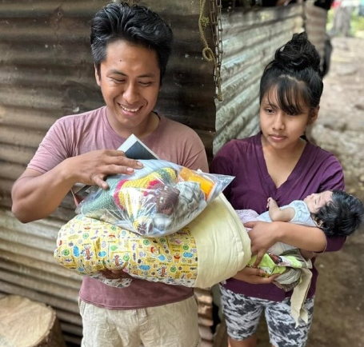
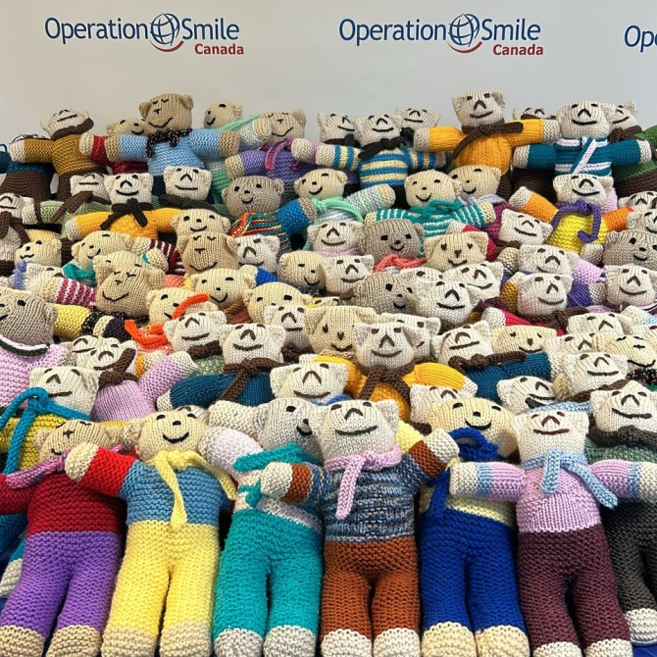
100 bears travelled with Operation Smile Canada to Santa Domingo, Dominican Republic, w here they were able to provide “comfort and companionship” to Operation Smile patients.
The Westover Layette Group prepared 3300 kits to be sent to many countries, in 2023. Some of these included a teddy bear. Pictured are some recipients of these kits in Guatemala. (Photo right)

Lesley Hunt (Wilts) Over the last six months, although I am the coordinator for Wiltshire,
all the donations have come from Somerset!
Two large bags of teddies have gone to Ukraine and another 2 bags full to the Christmas Shoebox Appeal.
The ladies of Clevedon produced a variety of lovely home knitted jumpers, all sizes and colours. They have been donated to our local hub for Ukrainian children living nearby.
They also made lots of pairs of cotton shorts. I have a friend who is visiting Thailand in the new year and she is taking them to donate to a charity which supports children from slum backgrounds in education.
All in all a very successful 6 months. Since Christmas I have acquired lots more teddies and bags which I shall be working on re homing over the next few days.

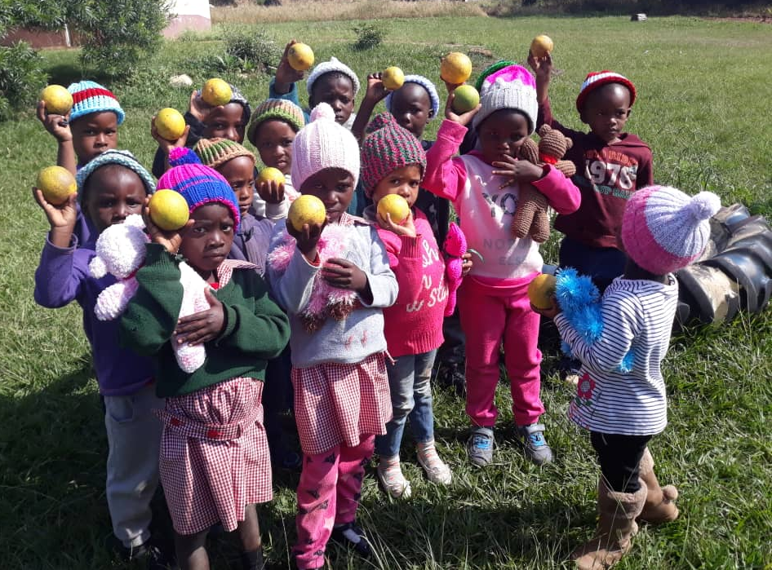
Greta Collier (South Africa)'KnitWits 4 the Needy'Crochet/Knitting Group After a crazy and difficult year, ‘KnitWits for the Needy’ have met regularly as usual, and made 100s of blankets, beanies, gloves, scarves etc. But of course! We did win the Rugby World Cup 2023 - so the year wasn't so bad after all!
We have donated baby items to The Baby Box which distributes to the new mums in the rural hospitals.
We chose to support the children who attend the Eco Brick-built Nursery Schools and who have no support - We were thrilled to donate 95 Teddies to them.
The donation of many blankets to 'Children of Fire' (badly burnt children) was an extremely difficult and emotional morning!
In the near future, Carolyn Steyn's Organisation '67 Blankets for Nelson Mandela Day', will be supporting the children who suffer from cancer who reside in the CHOC homes (Childhood Cancer Foundation) - by distributing 30 blankets, 30 beanies, as well as 30 Teddy bears which 'KnitWits 4 the Needy' made over the last year for their Christmas Teddy Tree.
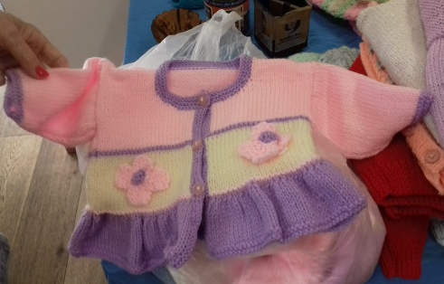
Sue Hardy (Barnsley) I am pleased to say that I have been able to join the ladies of the Cawthorne Mothers’ Union again this year. The year has not been without problems of falling numbers due to illness but we have managed to knit several items. These have been delivered to our local women’s refuge, Ukranian families, Shoebox Appeal and local care homes. We are hoping to continue our craft sessions in the New Year.

Sue Freeman (South Suffolk) Down in South Suffolk we are still knitting teddies, but there are fewer of us now. I will have to find more knitters. In the last year or so we have sent over 200 teddies to Ukraine. I have a contact who takes a van full of aid to Ukraine every month so the teddies hitch a ride in the van. They have mostly gone to orphanages and other children’s homes. Unfortunately I don’t get much feedback, but my contact is always pleased to have more bears.
Over the Christmas period I put a few teddies, in Christmas themed bags, in our local community pantry.

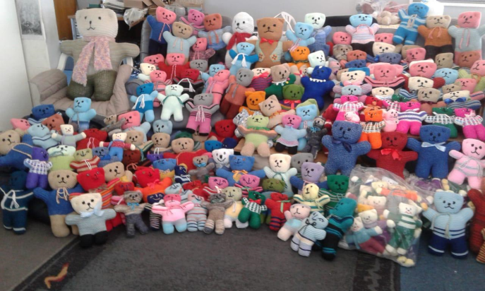
Dina Small (South Africa) We are a group called the ‘Threadbears’ in Port Elizabeth. As you can see, we do all sizes! The majority of our teddies go to a group called ‘Teddies for Tiny Tots’ and they make up care bags for new mommies which include products for mommy, clothing for baby and a teddy. They also receive donations and have a social worker on the group so that such donations go to the needy. I am part of the quilting group and we make baby cot quilts from material donations.

Mary Leech (Guildford) Since the last newsletter, all the bears that I have received have gone to children in the UK; by far the biggest recipient was a very socially-minded Company based in Manchester. Every Christmas they liaise with their local Social Services to provide Christmas gifts for the underprivileged children of Manchester and Leeds. They asked for 150 bears, which completely cleaned me out – thanks to Chris’ help, we were able to fulfil this request. A few glove puppets and soft toys were included with this consignment. Distribution was made easier by an employee at a London branch of the company who was able to collect them and see them on their way. (Quite a carful of bears!)
The children’s charity ‘Learning Space’ has received about 50. This charity works in Surrey with disturbed and displaced children. Each child is allowed to choose his or her own bear and a bag in which to keep it. Not just little children either: I was told that one 12 year old boy had been looking at the bears, and said, very wistfully, to his therapist that he does love bears …. Of course he got to choose one!
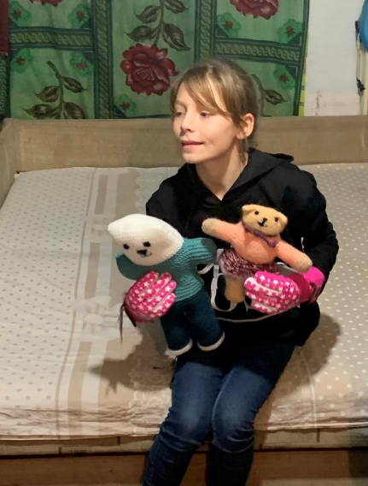
This is only possible due to the constant work of all the dedicated knitters who keep me supplied. Thanks in the past 6 months go to Ellen, Priscilla, Lorraine, Helen, Jenny, Trisha, Julie and the Tilford Gardening Club, Gillian, Gayle and Bina, and not forgetting the stitchers who have provided the bags: Jenny, Helen and Priscilla.

Patricia Peck (Reading, Berks My friends Jo and her husband Bruce go to Poland on a regular basis. They are planning another trip to Poland and Ukraine next month. I sent 466 teddies to Poland and Ukraine for Ukrainian refugees in August. This was followed by another 450 teddies in October and a further 140 teddies in November. This has only been possible thanks to the wonderful help of Colin and Tricia Gibb in St Albans collecting and packing the teddies ready for collection.

Diane Johnson (Co.Durham) Helping Hands Knitting Group We've been making items for Dementia care and Chemo patients over the last few months at Helping Hands, but not many teddies I'm afraid, as we moved and had to settle in our new Knit and Natter home.

Sally Despenser (Headington, Oxford) Shared Knitting and Crochet Group “People in our knitting group often say “I don’t know what I’d do without my knitting”. We can’t quantify the pleasure, companionship and sense of usefulness that it brings.“
Here is a list of this year’s output. We are increasingly aware of the need for blankets and warm clothes. We are concentrating locally on knitting for people who are sleeping rough, people seeking asylum, refugees, and families in need.
At the end of each year, we count up all the woolly goods made during the year, and which charities received them. Here are the ones for 2023:-
Blankets 100 Asylum Welcome, Oxford
Jerseys 122 Oxford Winter Night Shelter
Hats 129 Wheatley (Oxford) Refugee Group
Gloves 55 Helping Hands (co Durham)
Scarves 77 JR Neonatal
Socks 20 Florence Park Baby Cake Club
Soft toys 10 Oxford Baby Bank
Twiddlemuffs 9 Knit for Peace
Neonatal blankets 20
“ jackets 6

Jayne Young (Hampshire) Nothing from me for 23 due to illness. Hoping to start this Spring - some links established with Dorset police. Will be coordinating knitters and supplies with potential recipient organisations. Perhaps the newsletter could reflect this?
Will keep in touch on progress. Good luck Jayne – getting started is always the most difficult part!

From me in Kidderminster (Worcs)
The local charity Crafting for Communities helps to distribute many different items for me:-
Care homes – 23 octopus, 8 twiddle muffs, 32 wrist bands & 2 twiddle dice for dementia residents, 30 lap blankets, 4 shawls.
Local hospitals – 330 teddies, 28 dolls, 40 baby hats, 40 Worry Monsters (some of these go to schools & hospices too).
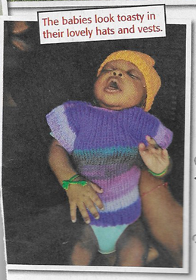
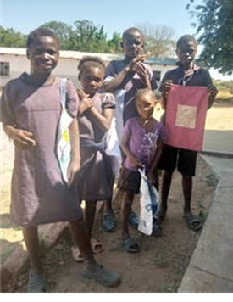
Zambia - 75 sturdy school bags & 80 pencil cases to a girls’ school via www.friendsofmonze.org
Uganda - 250 Fish ‘n Chip jumpers & hats for use by midwives (June), 250 (September).
Air Ambulance - A big sack of donated knitted toys, plus 2 of soft & boxed toys (August). In September another sack of knitted & one of donated toys, plus 28 hats, scarves & mittens ready for winter & Christmas sales; 5 more large dolls & 2 baby dolls with all their hand knitted clothes (November).

Local Mothers’ Union – 100 teddies to be taken to prisons for the inmates to give to their families at Christmas
Ukraine Centre, Edinburgh - 26 jumpers + hats, 6 cardigans + hats & mittens, 18 hat/scarf/mitten sets, 30 hat/mitten sets, all for refugees in Scotland.
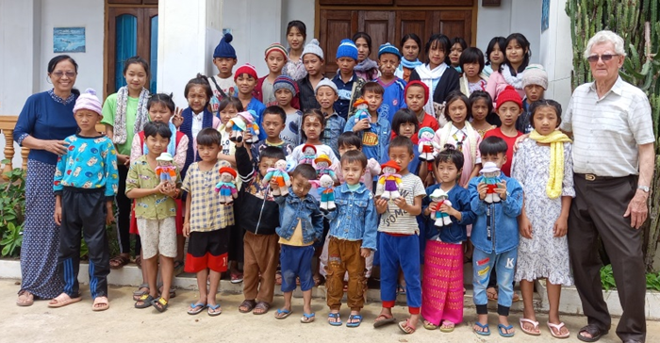
Burma – 30 teddies were sent earlier in the year. Here they are with their new owners!
I have just sent them some hats & 60 bags which each child can use as a ‘treasure bag’ to hang on the end of their bed.

Sedulo, a company in Manchester, runs a Christmas Toy Appeal supporting local families in need. When I offered to send them jumpers, hats, etc, I got this reply:-
“Oh wow, 100% we can use those! The number of children who just asked for some warm clothes every year is actually heart-breaking, so these will 100% go to making a real impact. Some of them literally ask for underwear or a hat and gloves, so they miss out on quite a lot of what it means to be a child at Christmas. Gestures like what you’re doing here help them to reclaim that a bit, so it genuinely is a huge impact.” I sent them 100 small teddies, 40 jumpers, another 32 with matching hats & 65 hat/scarf/mitten sets.

Gambia – www.projectgambia.org.uk - 49 baby blankets (1m square), 61 full size blankets, 3 sacks of baby cardigan sets (including 4 lovely baby dresses), 4 sacks of jumpers & 2 of cardigans, 47 drawstring bags for sanitary items; plus a box of school maths books.
A nursery school in Jan Jan Bureh, Gambia - 180 teddies & their bags for a teddy bears’ picnic next March! “We know that the teddies will be gratefully received by the head teacher, parents & children as they have very few toys to play with. Each child will be given their own teddy which they can take home afterwards. There are no parks or play areas in JJB & nothing interesting for them to do, so we hope this will give them something exciting to look forward to in the new year.”
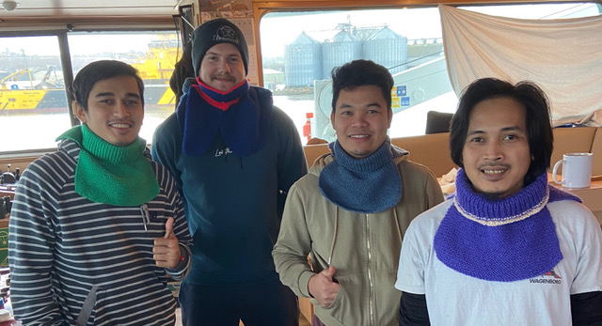
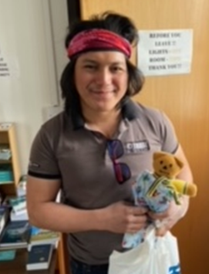
Sailors’ Society - 50 teddies in bags to the chaplain in Montrose. He also asked for some nice ladies’ hats & scarves which he could give to the seamen to take home for their wives. The seamen themselves have not been forgotten. I sent 20 neck warmers plus hats & balaclavas.

Lebanon - 3 large boxes of jumpers, cardigans, hat/scarf/mitten sets, little knitted dolls, small teddies & assorted puppets, large knitted toys as well as donated soft toys. “We have distributed all the wonderful items that you sent to the children of Lady of Lebanon school. A party was organised for them & every child was given a bag with presents inside including your beautiful work. Thank you so much for your contribution this year.”
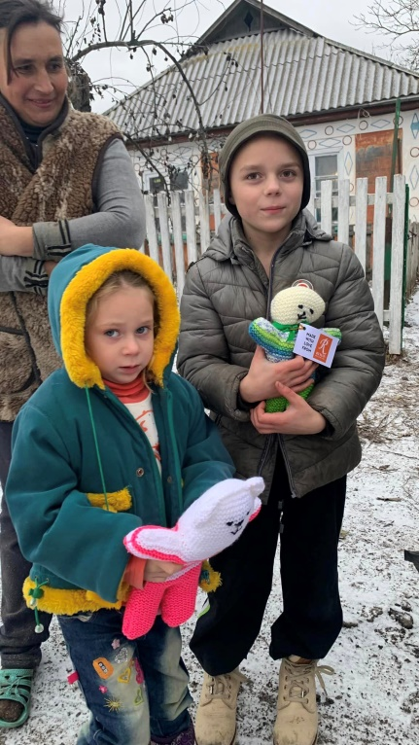
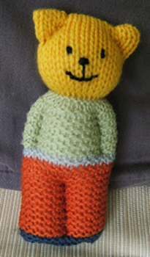
Ukraine I had so many things in my loft that we needed to make two trips to Leeds this year to deliver it all to the Yorkshire Aid Convoy. Included were: 91 blankets, 250 puppets, 100 teddies & their bags, 8 sacks of children’s hat/scarf/mitten sets, 2 sacks of adults’ hat/scarf sets, 2 sacks of cardigans, 4 sacks & 3 boxes of jumpers with hats, a box of baby clothes, plus many donated items:- men’s, women’s, children’s clothes, towels, blankets & sheets, a large bag of sanitary items, a box of boots & shoes. WOW!!!! It all went to Ukraine in September.

Christmas shoebox appeals - Operation Christmas Child (OCC) - 130 puppets, 160 hat/mitten sets, plus a large bag of donated small toys, puppets, bags, pencil cases, etc.
Teams4U - 120 puppets, 2 sacks of hat/mitten sets, a sack of hat/scarf sets, 31 square teddies, 14 little knitted mice, 6 hearts, a bag of small toys & crayons.
Local Baptist Church - 107 hat/mitten sets, 27 square teddies & 34 puppets for Ukraine
A ‘square’ teddy!

Best wishes,
Chris

